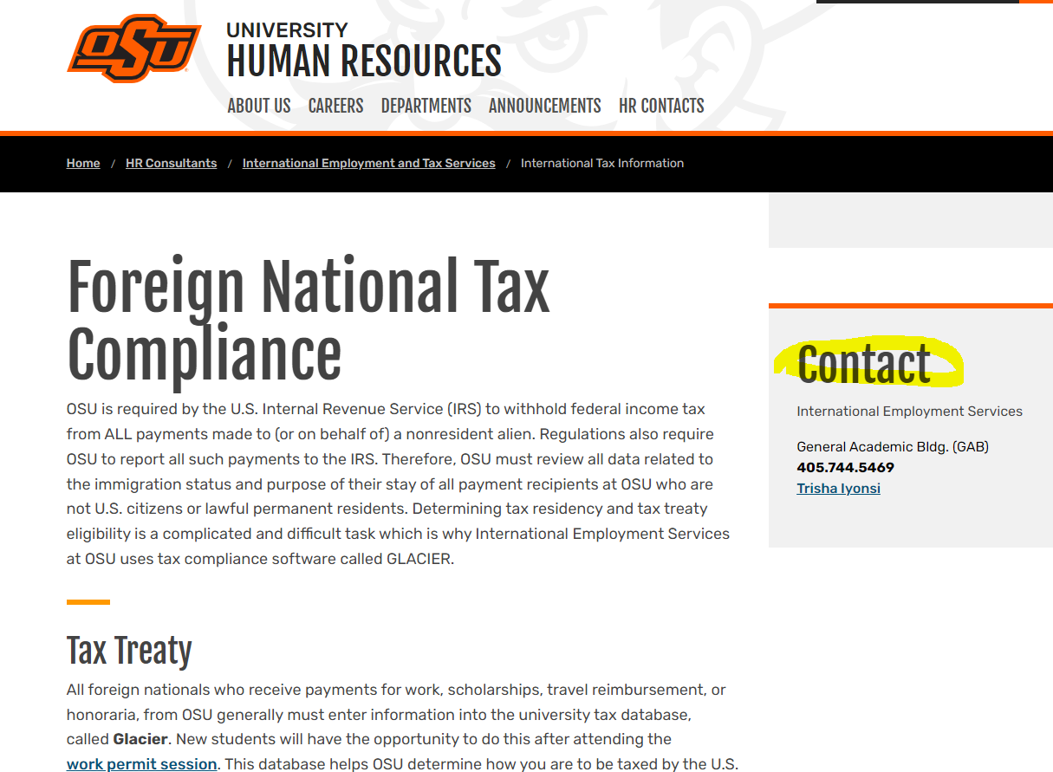

International Tax Information | Oklahoma State University (okstate.edu) – edits needed
Update Trisha’s contact information:
Tax & Compliance Services
Trisha Iyonsi
International Tax Accountant
405-744-8205

Tax Treaty section: Correct Trisha’s title to International Tax Accountant
Taxes (FAQ) section: Outdated, hide or remove for now
Sprintax sections – remove. We no longer use Sprintax

